Medadata-driven integration of dimensional data using DDI-CDI

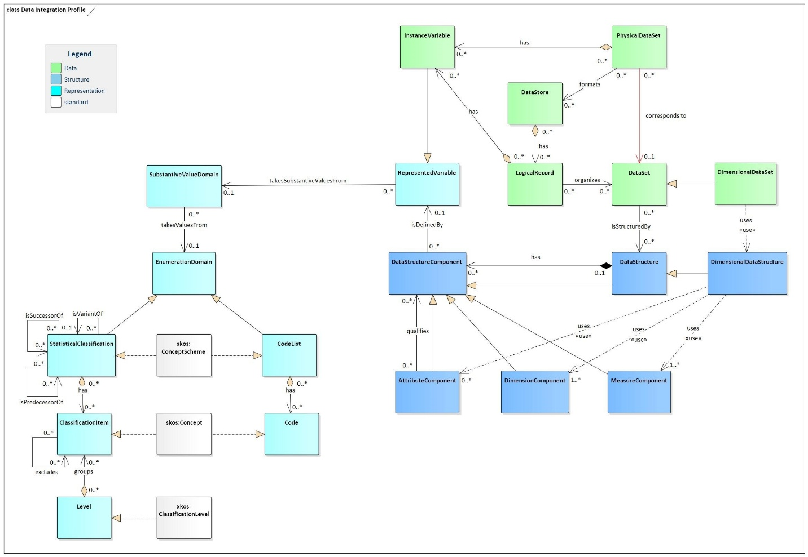

Step 1: Creating a data description profile for dimensional datasets
Our project used a Python script to generate a data description profile for dimensional datasets, leveraging a subset of the DDI Cross-Domain Integration specification (DDI-CDI).
Using the rdflib library, the script processes and filters classes and properties from static Turtle (.ttl) files, loading them into an RDF graph. The curated data is then serialized and stored in a new Turtle file (cdi_profile1.ttl) for further use.
https://github.com/Cross-Domain-Interoperability-Framework/undata_example_cdif/blob/dagstuhl2024/data/output/cdi_profile1.ttl

Step 2: Building a DDI-CDI-compliant dataset description for dimensional datasets
This step constructs a dataset description that aligns with the DDI-CDI model, using data extracted from SDMX APIs or CSV files.
- Load base DDI-CDI definitions from cdi_profile1.ttl into a new RDF graph object.
- Ingest dataset and code lists from SDMX API endpoints or CSV files.
- Define the DimensionalDataSet and DimensionalDataStructure objects.
- Add data structure components:
  - Add one DimensionComponent for each dimension column, assigning any applicable roles (e.g., GeoRole for geography, TimeRole for year).
  - Add one MeasureComponent for each column containing cuantitative or qualitative observation values.
  - Add one AttributeComponent for each column containing qualitative metadata.
- Create RepresentedVariable items
  - Define a RepresentedVariable for each dimension and measure, linking it to its respective data structure component.
- Link code lists
  - Represent each code list used in the dataset in SKOS, and associate them with their corresponding RepresentedVariable items via SubstantiveValueDomain.
- Export dataset description
  - Save the finalized DDI-CDI-conformant dataset description.

See Example 1 and Example 2
- 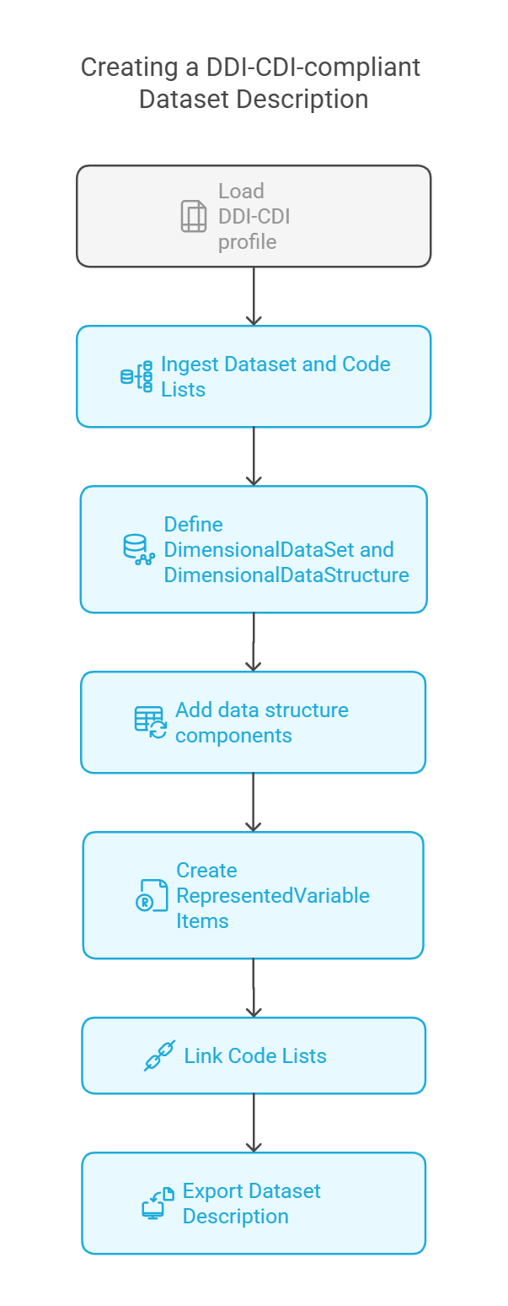
Step 3: Designing a data integration mapping template
To facilitate data integration, a mapping template is generated for two “source” DDI-CDI-profiled datasets, enabling alignment and further transformations.
The template includes:
- A list of all the data structure components of both source datasets—including attribute, dimension, and measure components, along with any specialization roles (GeoRole, TimeRole).
- Their corresponding represented variables and their associated code lists (with complete code and label pairs).
- A reference list of represented variables and their value domains (concepts and their code lists) to be used in the integrated “target” dataset.
Sept 4: Fill out the data mappings for from source concept and codes to target concepts and codes.
This can be done manually, or using automated or semi-automated mapping tools.
Step 5: Apply mappings to the source dataset.
Create a consolidated data package, consisting of:
- Integrated tabular dataset (serialized in CSV)
- A DDI-CDI-compliant description of the integrated dataset. This description contains a full description of the data structures and code lists.
See Example.
Step 6: Transforming integrated datasets for use in specific applications
Once datasets are integrated and described in DDI-CDI, they can be transformed into multiple representations. For example, they can be transformed into a set of SDMX artifacts for ingestion into a data dissemination platform, such as .Stat. They can also be transformed into a set of mcf files for ingestion into an instance of Google Data Commons, using schema.org.
The process of transforming SDMX-compliant data for use in Google Data Commons can more easily be automated by aligning both SDMX and Google Data Commons’ internal model with DDI-CDI.
